Jackson Lanham, Dhyan Patel, Lucas Sandlin, Mason Walker

Albonetti

INFO I101

3/2/26

Contributor

Katherine Johnson was a human computer for NASA. She was responsible for calculating flight trajectories for many space missions. Specifically, she calculated the trajectory for putting the first American in space, which built her reputation among the astronauts so much that John Glenn refused to fly unless Johnson verified the calculations. Although her contributions to history are great, she had to climb a mountain of discrimination to achieve them.
Katherine Johnson was an African American woman, which meant that she had to create opportunities that weren’t offered to her. She grew up in a time period that the highest public education for African Americans was 8th grade. Thanks to her parents, she was able to attend high school and then go to college to get a degree in mathematics and French. She took every math class her college offered and even had some created just for her. While working for NASA she was separate from facilities that her white coworkers had. She had to work, eat, and use the restroom in sperate facilities. Additionally, she had to be assertive in her work in order to achieve and receive credit of the things she did. Despite all of the roadblocks in her way she was awarded the Presidential Metal of Freedom, Silver Snoopy Award, Congressional Gold Medal, and much more.
Anita Borg and Katherine Johnson were the 2 finalists in our decision process. Although there were names from people that were from more modern history, we thought that because Borg and Johnson lived in times where segregation and discrimination were on full blast, their stories carried more impact for us. Ultimately, we decide to go with Johnson, because she died recently and was very public about the challenges she had to overcome.

Timelines
Team members responsible for each assignment: Project charter—Lucas, Project research—Jackson, Project website wireframe—Mason, Project: Peer Evaluation 1—Individual (everyone responsible for their own submission), Project Website Draft—Dhyan, Project Website feedback-Lucas, Project Data viz—Jackson, Project Final Website—Mason, Project final presentation(Submission)-Dhyan, Final Presentation(in lab)—Lucas, Project: Peer Evaluation 2-Individual(everyone responsible for their own submission).
The team will check in with each other every class period to get an idea of how much work is done, and how much still needs to be done. Plan to get everything done around a day before the due date, for example if the due date is Tuesday at 8:30, plan on having it done by end of the day on Sunday or Monday morning if you can. We should plan on using that last day to review the work and make any improvements or make it look nice.
Everyone on the group should skim through any changes made to an assignment and make sure they understand what that part does, and the member responsible for that assignment should read though it thoroughly, and make sure there aren’t any errors or anything that conflicts with something else. The person in charge of the assignment shouldn’t be the one having to do everything or micromanage everyone else. Everyone is responsible for their own part of each assignment, and the person in charge should just be looking over the work, and making a few milestones for each class period, and make sure they are achieved on time.
Once the everyone is done with all parts of a certain assignment, and it has been reviewed by everyone, the person responsible for the assignment should let everyone in the group know they are good to submit it. This is so everyone turns in the same version and body accidentally turn a unfinished version in. Once the leader for the assignment has let everyone know that it is good to turn in, everyone is responsible or turning the assignment in individually, and the leader of the assignments shouldn’t have to check in with anyone to make sure it is turned in.
Exposures
One exposure or this project is uneven participation and uneven work done by the members of our group. This could be a problem because if only 1 or 2 people end up doing most of the work for our group that could be bad for the final result of the project by causing more stress and affecting it. To make this not happen we will make sure to split all the tasks evenly and make sure to agree on who does what. We will also communicate most classes about what needs to be done and when and we will also make sure to speak up if someone needs help or is struggling. If the participation of one person becomes a problem then we will make sure to say that and so our group can do good and stay on track.

Another exposure is not understanding or missing some of the assignment requirements. This project has very many things to do like the individual research, the project charter, research summary, website wireframe, website draft, and many other things. Since there are so many parts to this project that most of them build on each other it could defiantly be easy to accidentally skip something or not understand what the assignment says. If this happens it would lower our grade which we do not want. To make sure this does not happen we will read the instructions carefully and the rubric before we start each assignment. We will also use a One Drive folder to keep all of our assignments and make sure that they are done. Also, before we submit the assignment we will all make sure to check that all of the requirements are done. If we did make a mistake we will make sure to fix it.

Management Plan
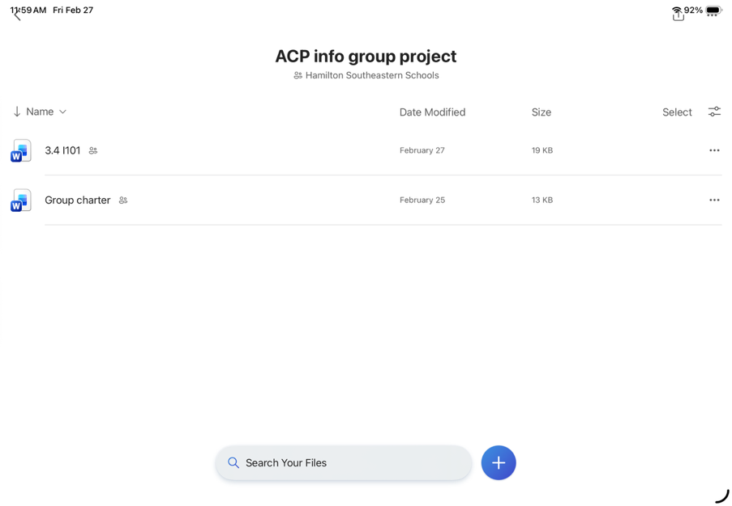
Our team coordinator is Lucas because he is responsible and has the most knowledge on Katherine. Communication is going to be a very important part of our project and so our plan is to discuss things either in person or by texting on iMessage into a group chat. This way we can communicate about smaller stuff anytime by texting about it, but we can also discuss bigger ideas in person as well. We plan to talk whenever we need to whether it’s over the phone or in person. We can text at home or wherever we are and we can talk in person during Ti or in Mr. Albonetti’s class in general. We also plan to have weekly meetings in person and on the phone. For on the phone, we plan to call from 4-5 on Wednesdays during red weeks, and on Tuesdays during silver weeks. For in person, we plan to meet during Ti in Mr. Albonetti’s room or the library on Tuesdays during red weeks and Wednesdays during silver weeks. Additionally, all of our work and notes will be stored in a shared folder.

